**LAB 7  
Creating Multiple IAM Users in Terraform**

**STEP 1: Create a new Directory.**



**STEP 2: Create terraform configuration file (main.tf)**

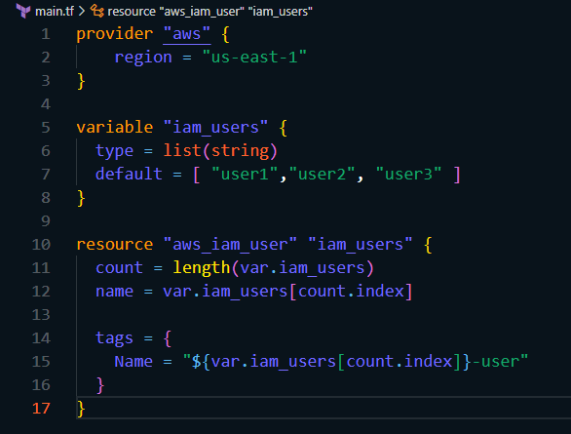

**STEP 3: Initialize and Apply.**

* **terraform init**

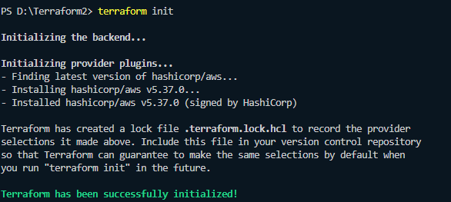

* **terraform apply**

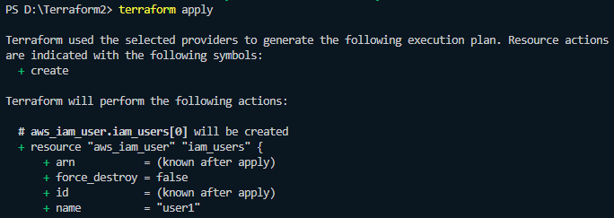

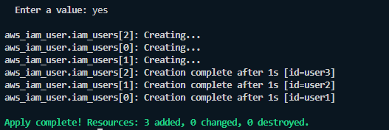

**STEP 4: Verify user in the AWS console.**

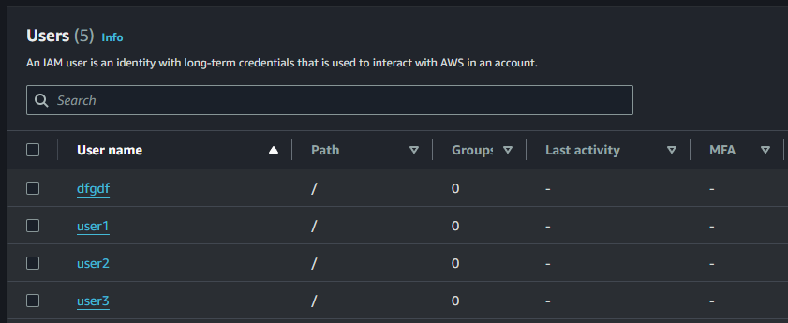

**STEP 5: Clean up.**

* After testing, we clean up the used resources by terraform destroy.

